**Prodigy InfoTech Internship**

**Task-1**

**Create a bar chart or histogram to visualize the distribution of a categorical or continuous variable, such as the distribution of ages or genders in a population.**

**Sample dataset :** [**World Bank Population**](https://data.worldbank.org/indicator/SP.POP.TOTL)

**Understanding the shape of the data**

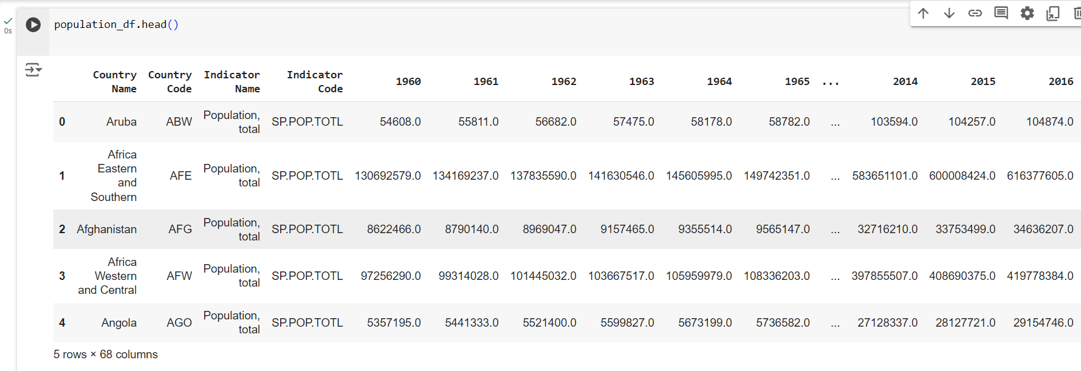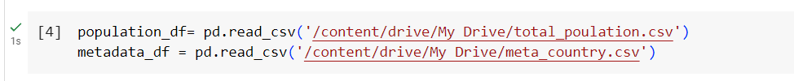

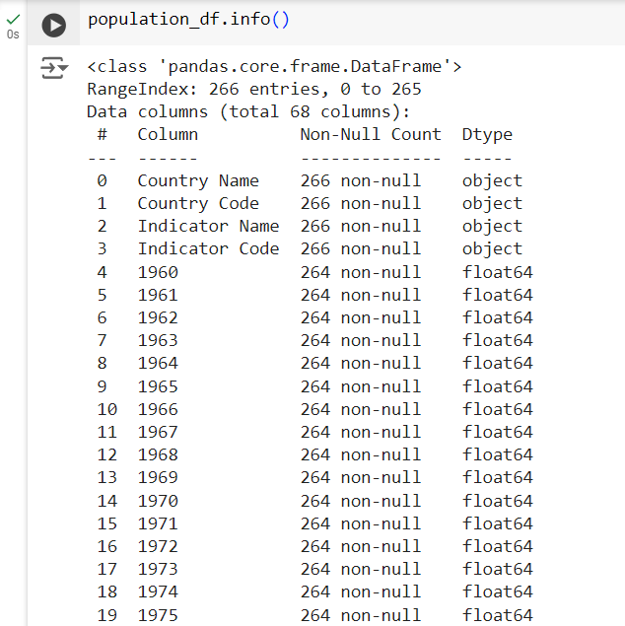

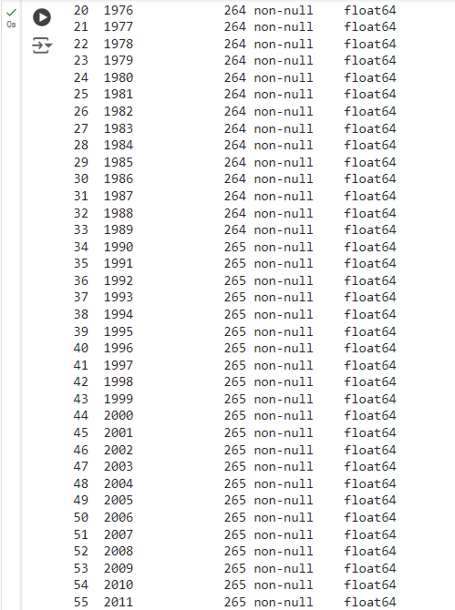

Cl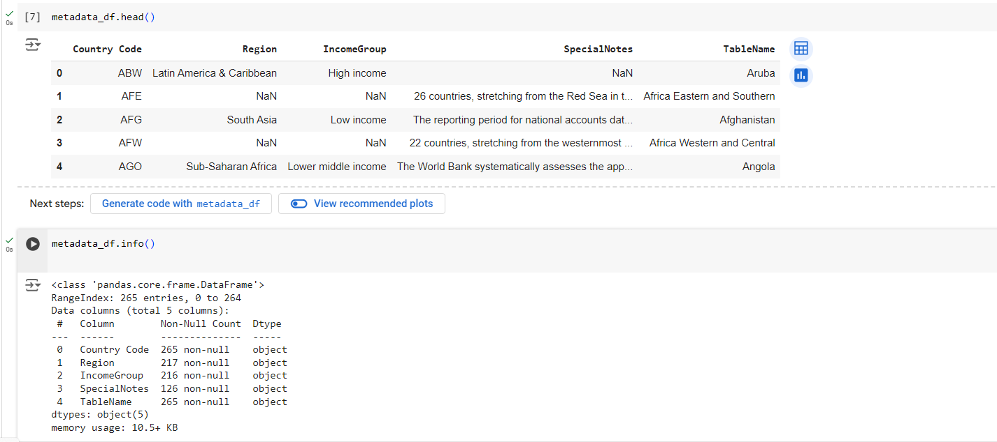

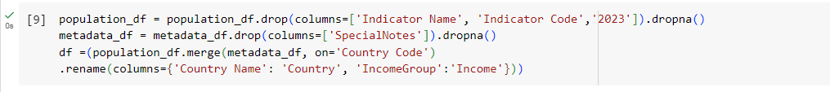Data Cleaning



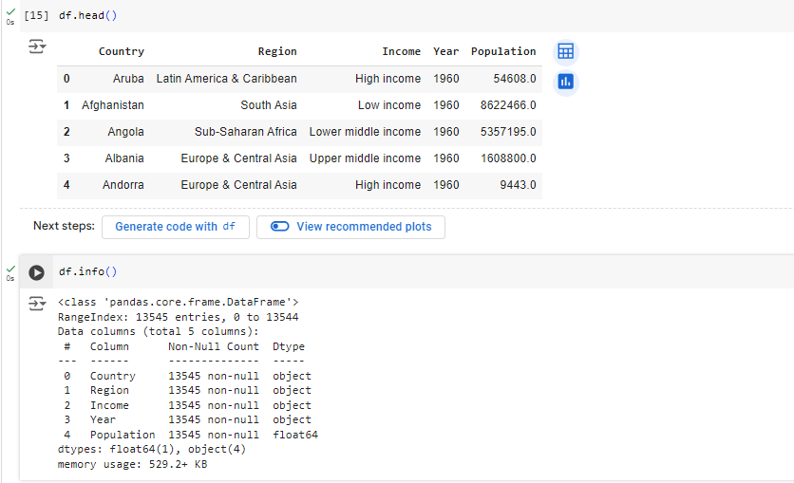

Data visualization ([Power BI Report](https://app.powerbi.com/links/idj5BO3ZeB?ctid=53bc88e9-b6c4-4d8e-8def-e26514fb6c59&pbi_source=linkShare)):

